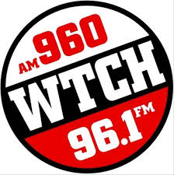
WTCH AM 960 & 96.1 FM will feature your High School Team Live and we invite you to share the word.
BOYS BASKETBALL
SHAWANO AT NEW LONDON
Friday March 6, 2020

The game will be broadcast live on 96.1 FM & AM 960. It will also be streamed at wtchradio.com as well. Click on the Listen Live WTCH link.
You can also visit WTCH on Facebook to find a link that you can share with your community and school.

We hope you can help us spread the word.

